The Torchbearers, Missouri State Council Past Presidents
Formally invite you to
The 39th Annual
Midwest Area Regional Council Conference
October 11-12, 2024

Sheraton Westport Plaza Hotel
900 West Port Plaza Drive
St. Louis, MO 63146
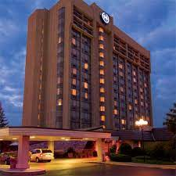
Registration - $175.00
Room Rate: $159.00 + Tax (No limit for quests per room)
Group rate available 3 days prior and post Conference
Free WIFI
Complimentary Parking
Free Airport Shuttle runs every 30 minutes

